Project 4 Task 2 – Order Management System

By Tianyue Xiao [tianyuex@andrew.cmu.edu](mailto:tianyuex@andrew.cmu.edu)

Description:

My application takes a search product id from the user, and uses it to fetch and display orders containing that product from OData.

Here is how my application meets the task requirements

1. Implement a native Android application

The name of my native Android application project in Eclipse is:

Project4Android

1.1. Has at least two different kinds of views in your Layout (TextView, EditText,

ImageView, etc.)

My application uses TextView, EditText and Button. See main.xml for details of how they are incorporated into the LinearLayout.

Here is a screenshot of the layout before the orders has been fetched

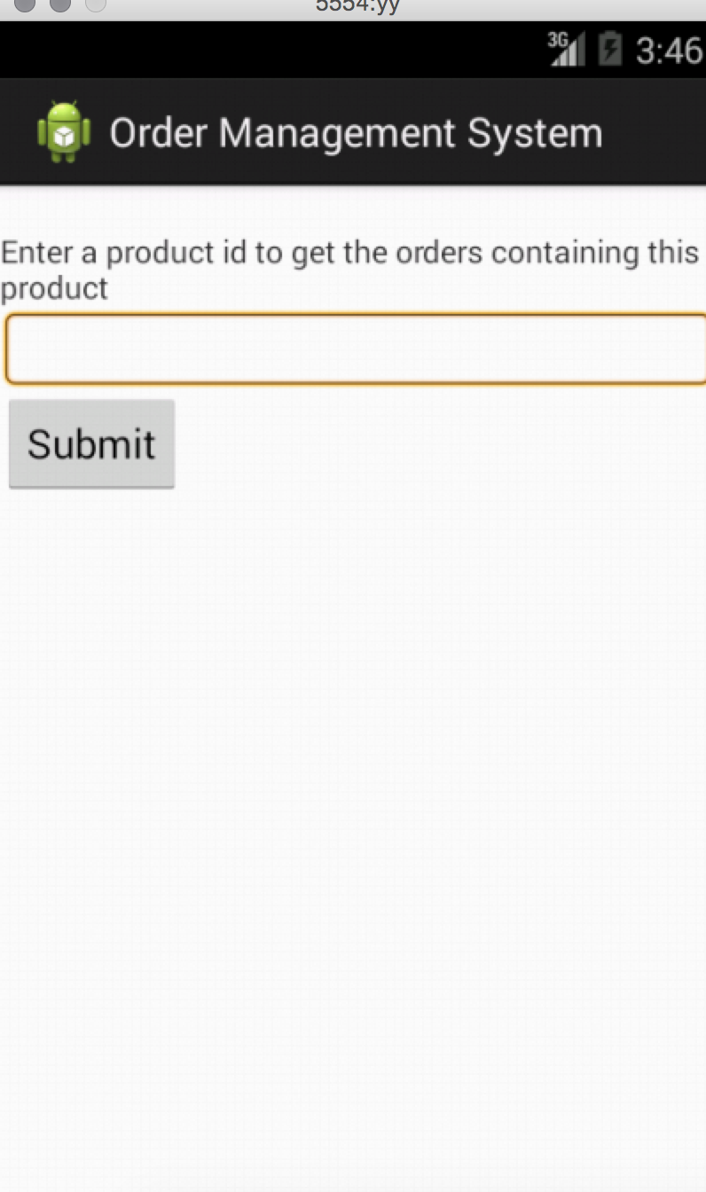

1.2. Requires input from the user

Here is a screenshot of the user searching for orders of product 1

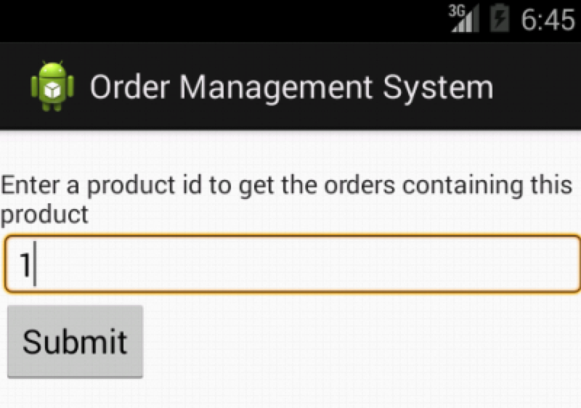

1.3. Makes an HTTP request (using an appropriate HTTP method) to your web

service